Dissertation

1. List the key findings – one sentence each, order from most exciting to least, or another logical order
2. Make figures for each key finding – place in pre-determined order
3. Write results around each finding – place in pre-determined order
4. Write methods around each result – only include methods needed to describe the science leading to the results presented
5. Write first paragraph of discussion – summarise all the key findings in order
6. Write the last paragraph of the intro – describes the research questions, hypotheses and/or objectives of the study – the study roadmap
7. Write the next paragraphs of the discussion – one paragraph per each key finding in order, discussions often also include a study limitations paragraph and a future research directions paragraph
8. Write the introduction paragraphs – one paragraph per topic of each of the key findings, should match with the content in the discussion paragraphs
9. Write the first paragraph of the introduction – provides the big picture context and sets out the clear knowledge gap of the study.
10. Write the conclusion paragraph – the last paragraph of the discussion or it’s own section, should explain why the research matters and put the key findings back into the big picture context set out in the first paragraph of the intro
11. Write the abstract – should include your entire pitch and should ideally follow the Nature abstract structure

**Methods**

SZU band selection

The selected wavelengths were then partitioned into five broad spectral regions to identify the most influential ones based on known pigment absorption regions and canopy structure. The five broad spectral regions considered were defined as: blue: 400–500 nm, absorption of chlorophylls and carotenoids; green: 500–600 nm, anthocyanin absorption; red: 600– 680 nm, absorption of chlorophylls; red-edge transition: 680–800 nm; and NIR: 801–985 nm, leaf/canopy structure and water absorption. (Beamish, 2019)

**Results**

Key findings:

H1

**How do Arctic Vegetation types be discriminate based on the mean and variance of hyperspectral signatures?**



Spectral properties by vegetation type

Vegetation types can be discriminated based on their spectral signatures, but exhibit variable and complex properties.

Visually vegetation types appear to be relativity similar based on the spectral properties of mean reflectance and spectral diversity (CV). Exception to this are the mean reflectance values of 2019 HE and KO vegetation types measuremtns, which where found to be significantly different from each other.

The tends in reflectance across all vegetation types and years corresponded with typical reflectance patterns across the electromagnetic spectrum. High levels of absorption where seen in the green and blue spectral regions that correspond with the chlorophyll, caratanoid and other pigment absorption. A relative with a “vally” before the red edge transition and high reflectance in the (late) NIR and IR regions caused by multiple scattering (woody material/compositional features)(maybe attempts to link to one vegetation type) (Wang et al., 2018).

Spectral properties by year

The sampling date of field spectral data resulted in clear differences in both the observed reflectance and spectral diversity observed between the two vegetation types. (This has significant implications on subsequent analysis) (Wang et al., 2018).

The spectral measuments from 2018 showed similar reflectance patterns to across the spectrum but overall exhibited far less diferrentiations between vegtetation types and low and contant values spectral diversity.

The observed spectral differences were far more pronounced in 2019 spectral data, with KO exhibiting a significantly higher mean reflectance (xxx vs xxx), and HE exhibiting a visually higher and less variable spectral diversity, but still have a credible interval that overlapped zero.

Overall spectral mean had a greater correspondence with vegetation type than spectral diversity.

The spectral discrimination of vegetations types through an ordination approach was possible when a sufficiently large distance was oserved in a spectral feature space and when there was greater inter-group variation than intra-group variation. (Clark et al., 2005). When ordinated, measurements discriminated by year and to an extent vegetation type.

2018 and 2019 data discriminated amounsts each other, with HE and KO for 2018 having reserve positions in spectral space. Mixed vegetation measurements of both HE and KO from 2019, did not discriminate into two groups indicating that spectral discrimination of types may be less pronounced across wider landsapes with patches with less defined (characteristic compositionsal traits of each vegtype).

Discussion for H1: Spectral measurements from mixed types both visually (at least mean reflectance) and when ordinated should discriminate into two groups, as measured plots were selected based on exhibiting typical species compositional charactersitcs of one of the vegetation types.

Do vegetation types discriminate based on spectral signatures? mixed results. Based on mixed measurents no, as plots that were selected based on predicted vegetation type did not exhibit spectral properties that corresponded with collison measurments. In an ordination approach a purpendicalr (rather than parallel pancake shape should have been seen).

**Does band selection influence correspondence between spectral diversity and vegetation types**

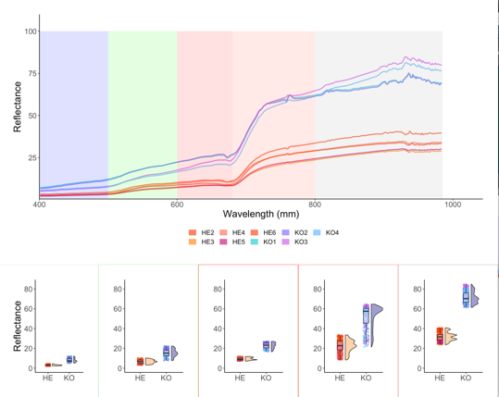

*Note that for some reason axis aren’t nice…*



Spectral mixture analysis

The use of SMA and SZU enabled the identification of respectively red and green spectral regions to be best suited to the discrimination of vegetation. This differs from what visually would be expected to be the most discriminative regions, as NIR and IR regions visually exhibit the largest difference (figure).

Furthermore the SMA and SZU allowed the detection of specific band (in proxy chemical/structural properties) that are most relevant to discriminating vegetation types.

Band selection via spectral zone unmixing determined that single bands within the green region of the electromagnetic spectrum where the most discriminative for vegetation type differentiation. (ie “ i.e., maximizing between community variability while minimizing within community variability”). (Beamish, 2019) (explain pigments etc anthocyanin absorption?).

(Make ISI relative ?)

Relative ISI is the regions ISI, when adjusted have an equal number of band included ISI /(number of bands in region/numbers of bands in IR)

|  |  |  |  |  |
| --- | --- | --- | --- | --- |
| Region | ISI | Relative ISI  (need to change as it no longer is ISI) | Number of bands selected | Selected band ISI |
| Blue | 1265 | 2593 | 10 | 211 |
| Green | 1135 | 2252 | 8 | 154 |
| Red | 912 | 2244 | 3 | 56 |
| NIR | 1456 | 2325 | 12 | 225 |
| IR | 2557 | 2557 | 30 | 662 |

Respectively the red and green regions of the electromagnetic spectrum had the lowest sum of ISI values (xxx & xxx) and were the most discriminative for vegetation type differentiation. The red-edge transition (~700 nm) had relative peak in ISI values , followed by relatively low and consistently stable ISI values in the NIR plateau. The IR region was the least discriminative. Yet the red and IR regions respective stability/variability in ISI values, resulted in significant misrepresentation of these bands in the SZU band selection.

The applied three-wavelength moving window for minima selection resulted in the greatest propositional inclusion of bands from the IR region of the spectrum. Although bands in the IR regions where the least discriminative for vegetation type discrimination (what is my metric) many bands from the IR region were included due great variability in present in this region.

(link in discussion by IR could be the most spectrally variable



Plotting DISI i accumulation ( quantification of the amplitude by which fraction estimate accuracy if SMA deceases with the addition of extra band) indicated that the global maxima was at one selected. This means that for each additional band included into the selection, the proportion of information gained through inclusion (accuracy of model) is less than the additional variability added (Somers et al., 2010). Local minima selection ideally reduces discrimination of the selection of bands in veritable spectral regions and ensures the inclusion of bands across the electromagnetic spectrum (rather than just one band). Yet here, it resulted in underrepresentation of stable and highly discriminative regions of the spectrum, and inflating the total number of included bands (ideally a number close to one, while still providing decent representation of variation across the electromagnetic spectrum)

Models

-> link to models: while band selection via SZU did significantly increase the observed relationship between vegetation type and spectral mean in a mixed effects linear model, it decreased the relationship between vegetation type and spectral diversity and resulted in the worse fit out of the 4 models.

Supervised band selection resulted in the best model, both when include only 2019 aswell as 2018+2019 data.

spectral dimensional reduction via both supervised algorithmic band selection increased the correspondence between vegetation type and mean reflectance, but not spectral diversity.

Write about 3 point vs 5 point minima, and the inclusion of highly variable parts of the spectrum). (could look into 5 point window). Discussion this could significantly improve model accuracy.

Add ISI table by region? May need two ISI selection, one for HE the other for KO?



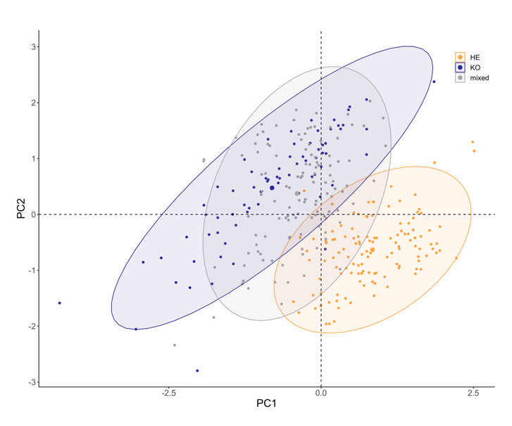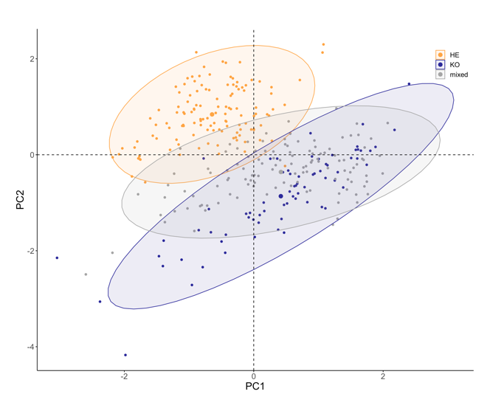

Ordination

When 2019 spectral measurements were re-ordinated following band selection, measurements with reduced spectral dimensions did visually better discriminate amounts vegetation types. Furthermore both mean reflectance values and spectral diversity aligned closer to PC1 (and contributed/explained more of the variation between measurments).

Ordination also suggests that mixed vegetation based on spectral properties tend to correspond closer with KO vegetation.

**How does spectral diversity relate to species richness, evenness, and soil-background?**









**Are closer measurements more similar than more distant measurements?**

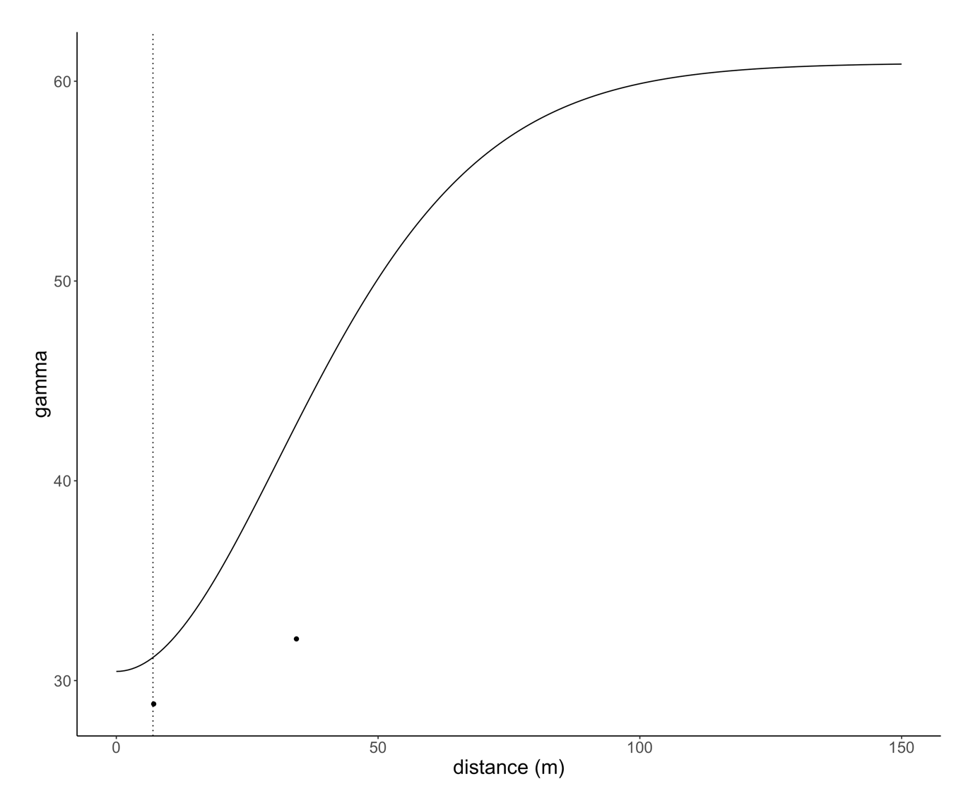

Nugget-to-sill ratio indicates  
the degree of spatial dependence in the data. <0.25 = strong spatial dependence  
0.25-0.75 = a moderate spatial dependence